**Wi-Fi OPTIMIZATION APP  
(PROJECT ORION)**

**TEAM ECHELON**

**Ahmet NAsuhcan ÜNLÜ|İlker mavİlİ |Ozan İrfan BAYAR**

SYSTEM REQUIREMENTS

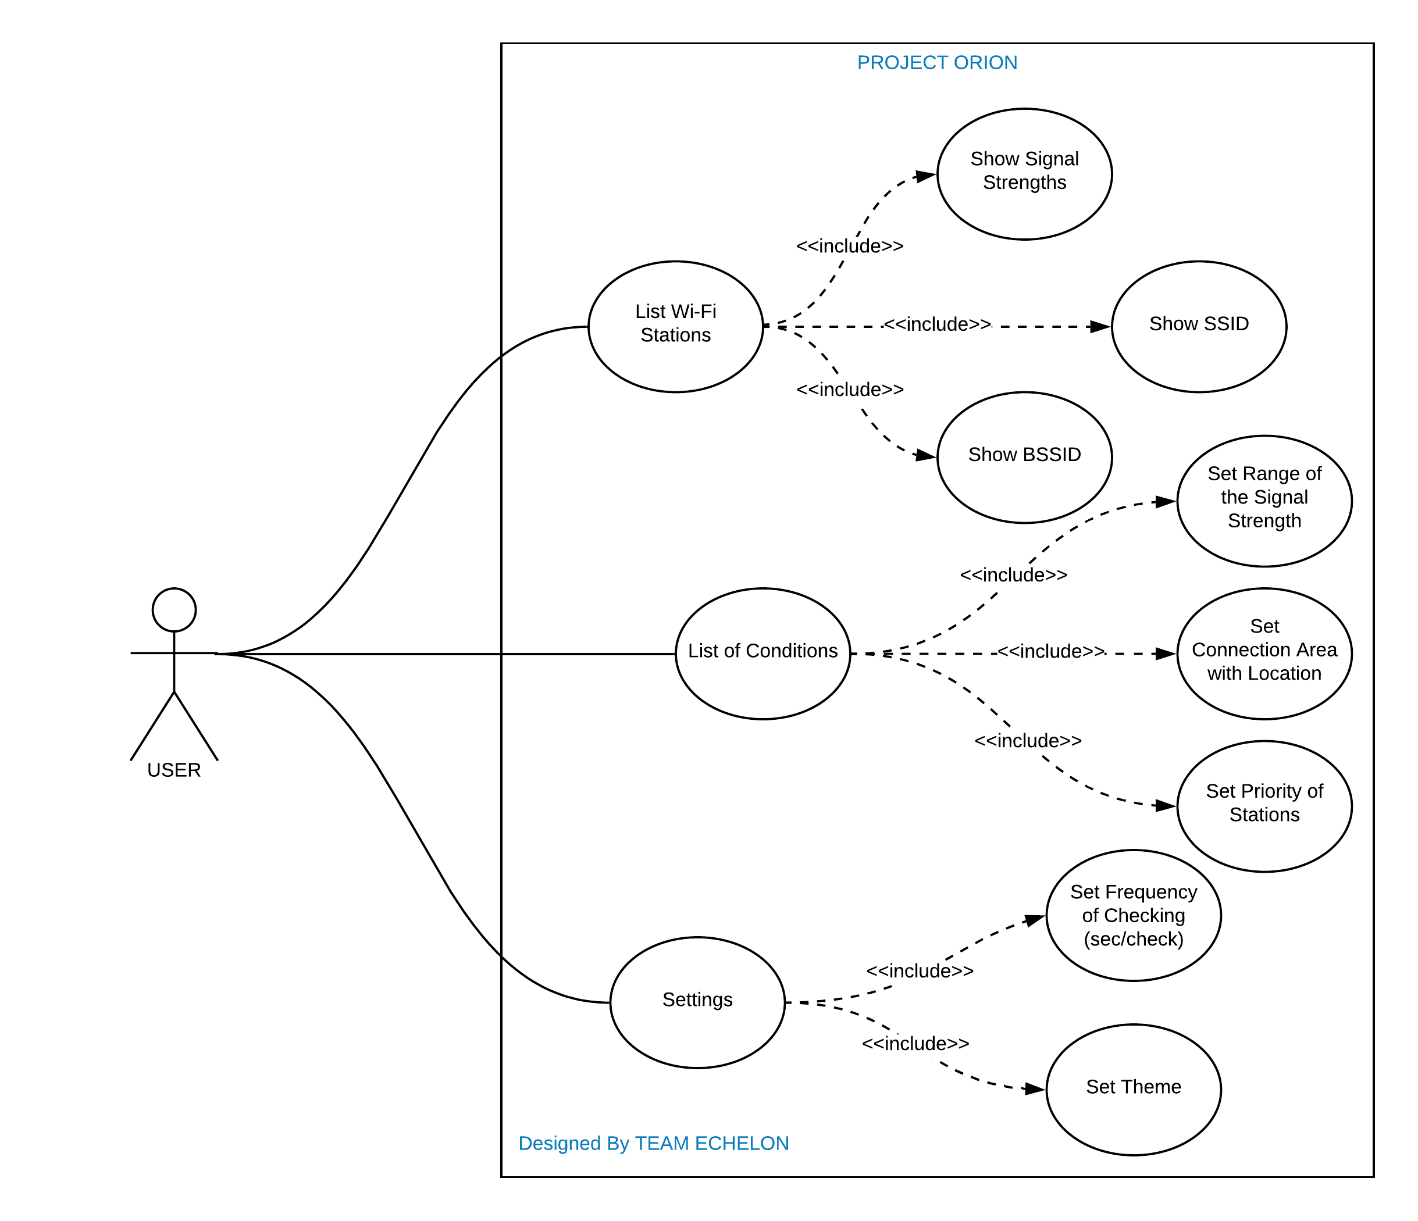

**USER 1: ⭐️⭐️⭐️⭐️⭐️**

I am a developer and I live in a big flat. My working space is at the furthest point to the router. For that reason, I am using my old router as an access point but when I go to my room, my phone does not switch automatically to the Wi-Fi which has the strongest signal. I can set the range of signal strength by pressing “List of Conditions” and pressing again to “Set Range of the Signal Strength” so I do not need to make an intervention thanks to the Orion.

**USER 2: ⭐️⭐️⭐️⭐️**

I am a student and have to stay in a dormitory. The dormitory does not have a good wireless technology, there are separate Wi-Fi for each floor but we are not able to connect automatically to the nearest Wi-Fi. And that causes increase of the signal attenuation. To handle this issue, I recommend Orion app to my dormitory friends. In addition, I can set dark theme to take care my eyes from blue lights by going into “Settings” and pressing “Set Theme”.

**USER 3:** **⭐️⭐️⭐️⭐️⭐️**

There are two access points in my office that placed in different points, but I cannot switch Wi-Fi automatically. I do many phone calls due to my job and need to use my battery efficiently too. I have used many apps to solve this but they drain the battery too fast. Orion has an option which allows setting the checking frequency to reduce battery consumption. It is available in the “Settings” as “Set Frequency of Checking”. That’s why I am using it and recommend to everyone in my office.

**USER 4: ⭐️⭐️⭐️⭐️⭐️**

I was working in a big company, but I have to work at home now due to Covid-19. I bought an access point to place it in ground floor because I want to use my computer in my garden while working. The connection strength is getting weak when I go to the downstairs during the work. I have marked the spots from “Set Connection Area with Location” in “List of Conditions”. That’s why I love Orion. It changes the Wi-Fi networks instantly according to the signal power.

**NONFUNCTIONAL REQUIREMENTS:**

* **Security**
* **Efficiency**
* **Usability**
* **Performance**
* **Manageability**

**GLOSSARY**

**Wi-Fi (Wireless Fidelity):** Wi-Fi is a wireless networking technology that uses radio waves to provide wireless high-speed Internet access.

**Signal Strength (dBm):** Signal strength is a measure of how well data is transmitted e.g. via Wi-Fi through electromagnetic waves.

**Router:** A router is a networking device that forwards data packets between computer networks.

**Access Point:** It is a networking hardware device that allows other Wi-Fi devices to connect to wired or wireless network.

**Signal Attenuation:** Signal Attenuation is the loss of signal strength in networking cables or connections.